Since we just got the new 2018 figures, I thought it would be a good opportunity to update my graphs,

|  |  |
| --- | --- |
| 1  2  3  4  5  6  7  8  9  10  11  12  13  14  15  16  17  18  19  20  21  22  23  24  25  26  27  28  29  30  31  32  33 | **library**(XML)  **library**(stringr)  **url**="http://www.nserc-crsng.gc.ca/NSERC-CRSNG/FundingDecisions-DecisionsFinancement/ResearchGrants-SubventionsDeRecherche/ResultsGSC-ResultatsCSS_eng.asp"  **download.file**(**url**,destfile = "GSC.html")  **library**(XML)  tables=readHTMLTable("GSC.html")  GSC=tables[[1]]$V1  GSC=**as.character**(GSC[-(1:2)])  namesGSC=tables[[1]]$V2  namesGSC=**as.character**(namesGSC[-(1:2)])  Correction = **function**(x) **as.numeric**(**gsub**('[$,]', '', x))  YEAR=2013:2018  **for**(i **in** 1:**length**(YEAR)){  y=YEAR[i]  grants= **function**(gsc){  **url**=**paste**("http://www.nserc-crsng.gc.ca/NSERC-CRSNG/FundingDecisions-DecisionsFinancement/ResearchGrants-SubventionsDeRecherche/ResultsGSCDetail-ResultatsCSSDetails_eng.asp?Year=",y,"&amp;GSC=",gsc,sep="")  **download.file**(**url**,destfile = "GSC.html")  **library**(XML)  tables=readHTMLTable("GSC.html")  X=**as.character**(tables[[1]]$"Awarded Amount")  A=**as.numeric**(**Vectorize**(Correction)(X))  **return**(**c**(**median**(A),**mean**(A),**as.numeric**(**quantile**(A,(1:99)/100))))  }  M=**Vectorize**(grants)(GSC[1:12])  **plot**(M[3:101,8],(1:99)/100,type="s",xlim=**c**(0,130000),xlab=  **paste**("Annual Discovery Grant (CAN) - ",y,sep=""),ylab="")  **lines**(M[3:101,5],(1:99)/100,type="s",**col**="red")  **lines**(M[3:101,4],(1:99)/100,type="s",**col**="blue")  **abline**(v=M[3,5],lty=2,**col**=**rgb**(1,0,0,.4))  idx=**which**(M[3:101,8]&lt;M[3,5])  **lines**(M[2+idx,8],(idx)/100,type="s",lwd=4)  **legend**("bottomright",**c**("maths","physics","chemestry"),  **col**=**c**("black","red","blue"),lty=1,bty="n")} |

With those functions, I plot the cumulative distribution functions for three disciplines, manely *maths*, *physics* and *chemistry*. I added a line for the lowest value in physics (the vertical line), and the bold line shows the proportion of researchers in maths who got *less* than the lowest amount in physics,

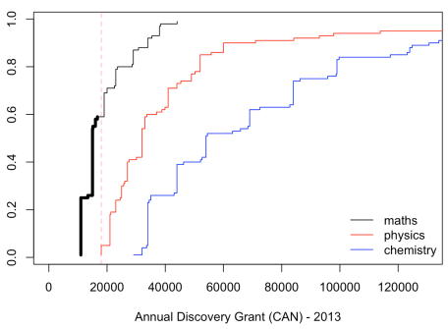

Hence, in 2013, 60% of the researchers in maths get less than any researcher in physics (and more than 90% in maths get less than *any* researcher in chemistry). Then, from 2014 to 2018, we get

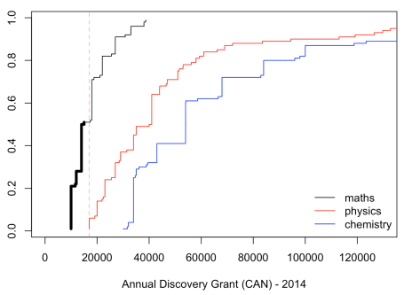

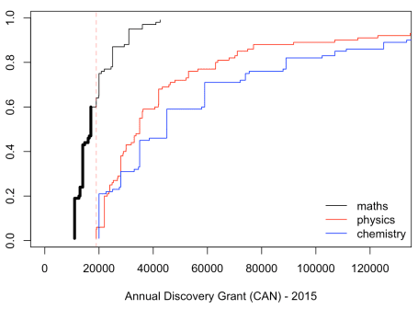

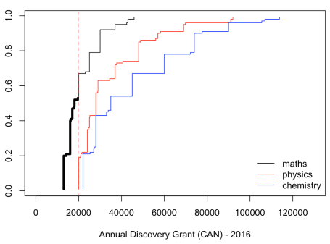

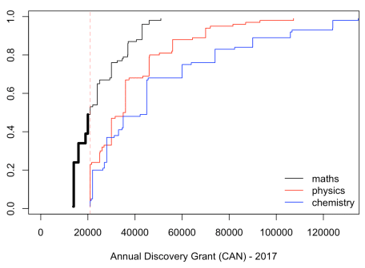

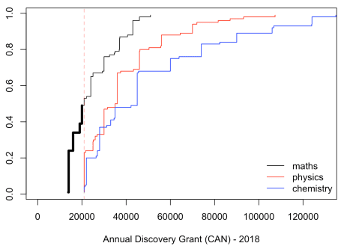

It is rather constant : 50% of the researchers in mathematics in Canada get less than any researcher in physics, or in chemistry. I don’t understand why, but it’s interesting to observe that this is very stable…